PROTOTYPE
Movement Game
An accessible group activity for older adults in Māori communities
31 July 2026

Summary
This report presents a low-fidelity prototype for a facilitator-supported movement and quiz game designed for older adults, including kaumātua in Māori community settings. The experience combines a guided sequence of five to eight gentle movements with a short quiz and a shared progression system. Players participate in Seated Mode or Standing Mode, complete movements at a comfortable level, press OK to confirm completion, unlock a pātaka-themed quiz screen, and earn Wellbeing Points that grow a virtual tree.

1. Background
The initial concept was inspired by Hole in the Wall, where a player positions their body to match a shape. The concept has been adapted for a community activity with lower physical demand and a stronger cognitive and social component. An on-screen avatar demonstrates each posture, an approaching shape adds anticipation, and a quiz provides variety after the movement sequence. The design supports group facilitation in a community centre, kaumātua programme, retirement village or whānau gathering.

2. Detailed Game Design

2.1 Participants, Setting and Equipment
A prototype session is designed for one or multiple players and one optional facilitator. A session lasts about 5 to 10 minutes for each round, with breaks available at any point.
This game design for minimum device requirement, such as television with remote control and laptop with mouse.

Core Gameplay Loop
Step One: Choose a mode. The player can select Seated Mode or Standing Mode according to mobility, balance and comfort. Figure 1 presents a selection with two large options, which gives the player control over physical demand before the activity starts. Seated and standing options are shown side by side so that neither mode appears to be a lesser version of participation.
Step Two: Observe the sequence. The avatar demonstrates a series of gentle movements (5 - 8 pictures). Each movement includes a short observation and preparation period. Figure 1 demonstrates separates observation from performance that the avatar uses a clear silhouette and an uncluttered background so that the direction of the arms and body remains the most prominent information. One movement is displayed at a time as which this lowers memory demand during the physical action and gives the facilitator an opportunity to demonstrate an adapted seated or supported version, but the full round still contains five to eight movements, preserving the intended amount of activity.
Step Three: Copy and hold. The player copies each posture within a comfortable range and holds it for approximately 3–5 seconds while the animated shape approaches. Figure 3 presents the major actions for this step that the approaching shape retains the playful Hole in the Wall inspiration and introduces timing without requiring fast movement. Additionally, a hold of approximately three to five seconds provides a clear end point.
Step Four: Confirm completion. After the full sequence, the player or facilitator presses OK. Safe adaptation counts as completion.
Step Five: Unlock and answer. The pātaka animation reveals one short quiz question. The player selects an answer with the remote control, mouse, cards or speech.
Figure 4 demonstrates the mechanism for the Step Four and Five that the quiz follows the entire movement sequence, creating a simple reward boundary between physical and cognitive activity.
Step Six: Receive progress feedback. The game awards Wellbeing Points, updates the progress bar and advances tree growth. The player then continues, pauses or finishes.
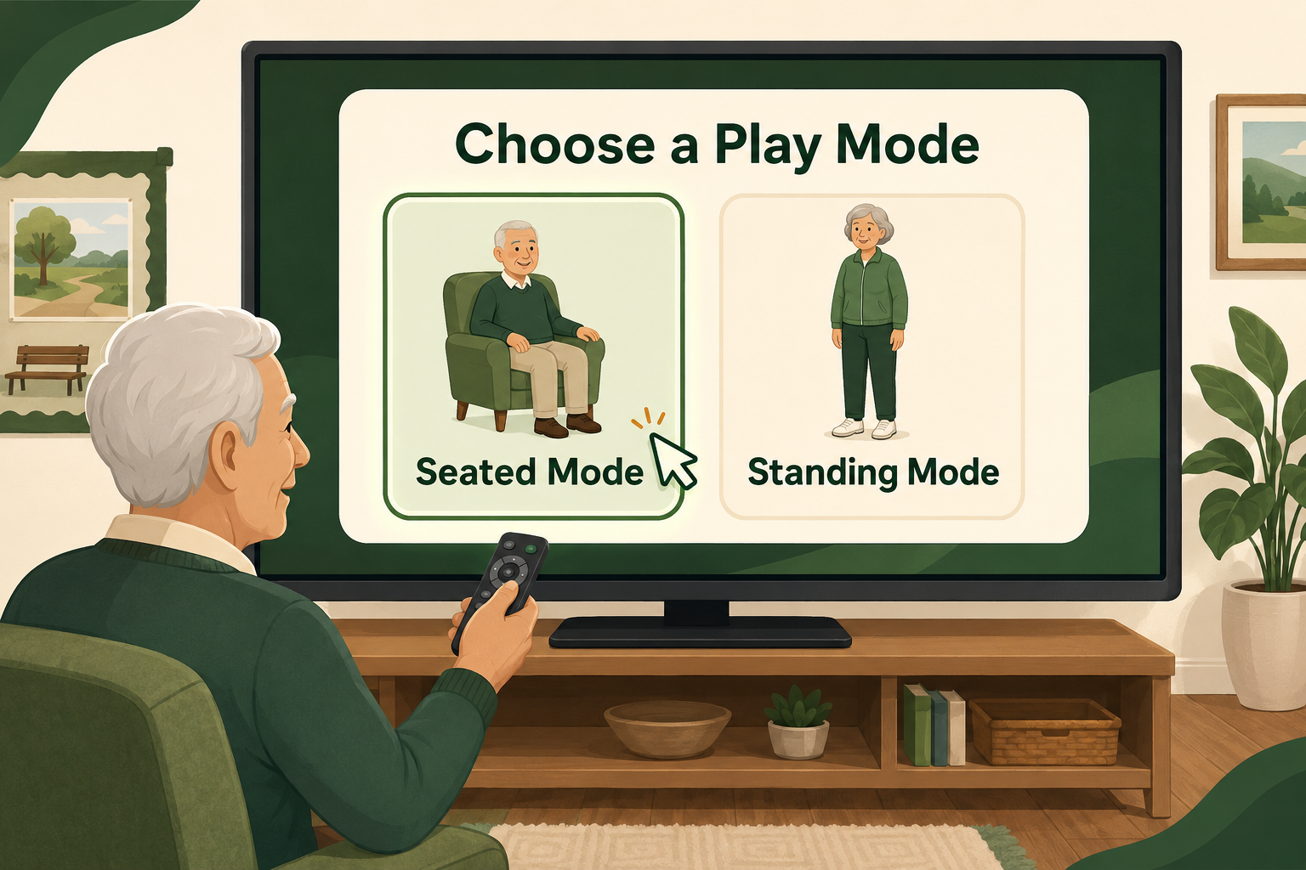 | 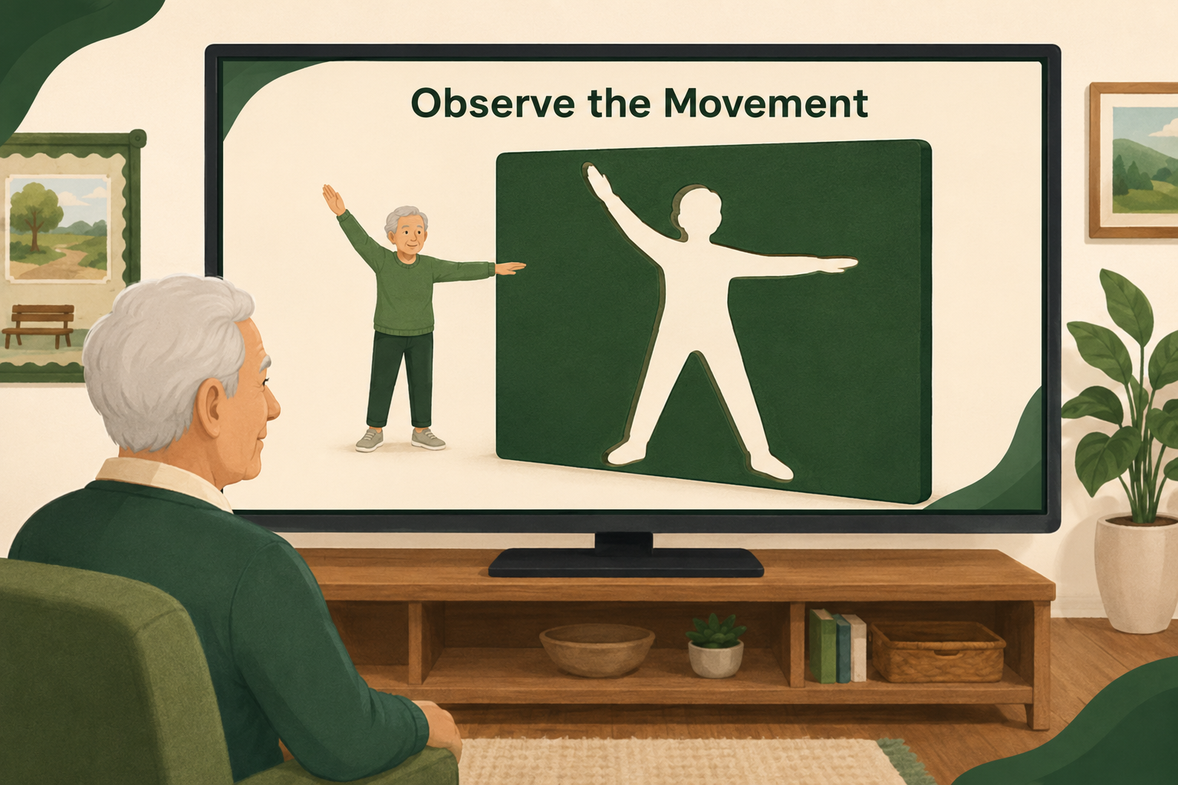
Figure 1. The player chooses Seated Mode or Standing Mode before the movement sequence. | Figure 2. The on-screen avatar demonstrates one movement from the 5–8 movement sequence.
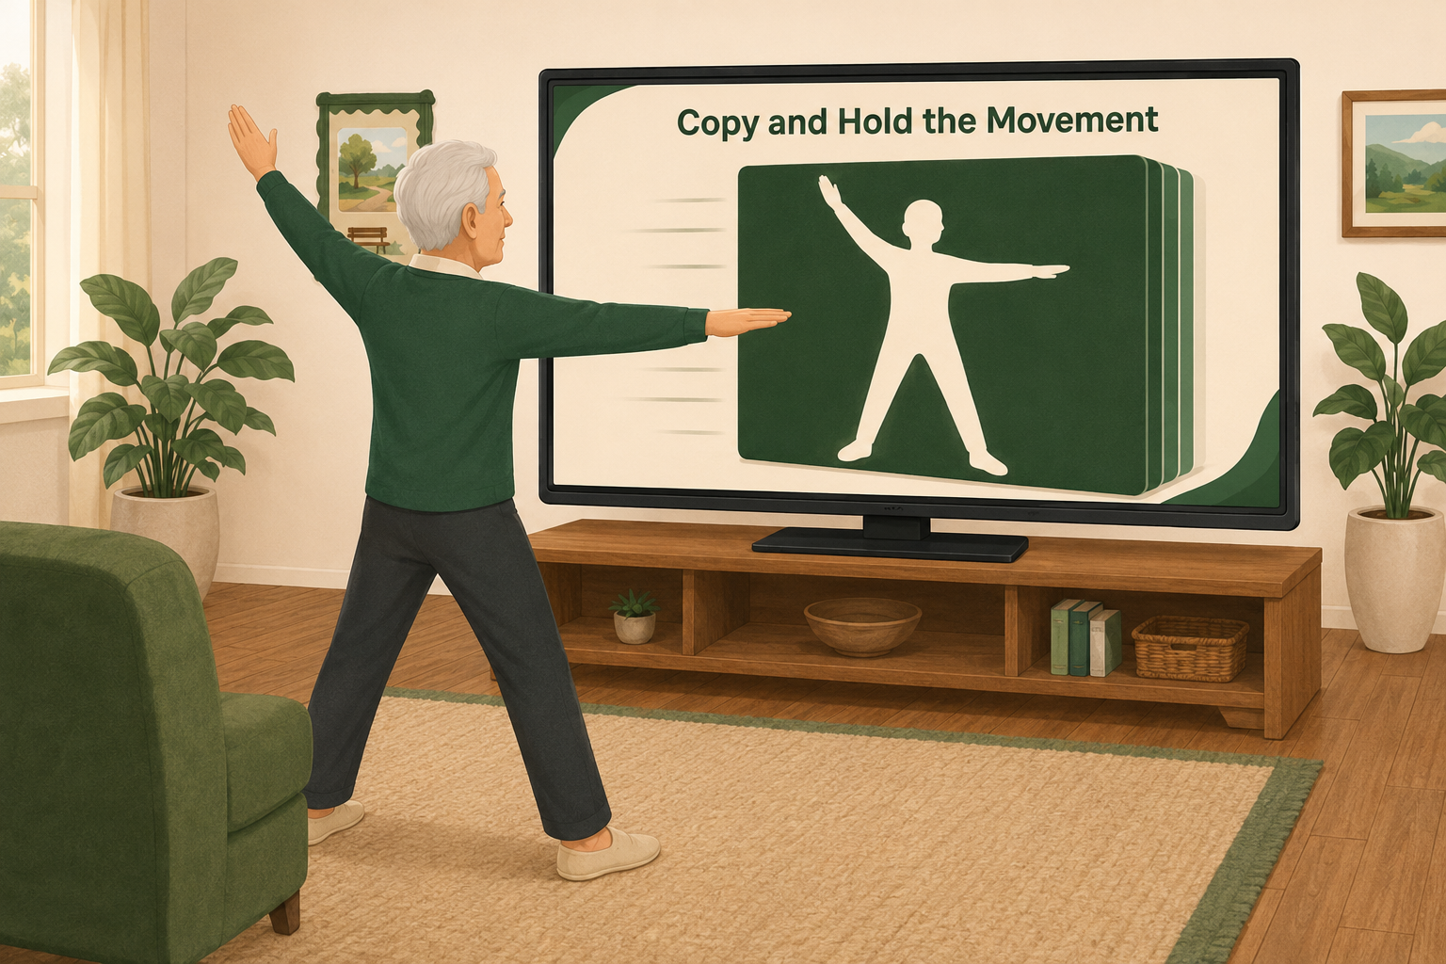 | 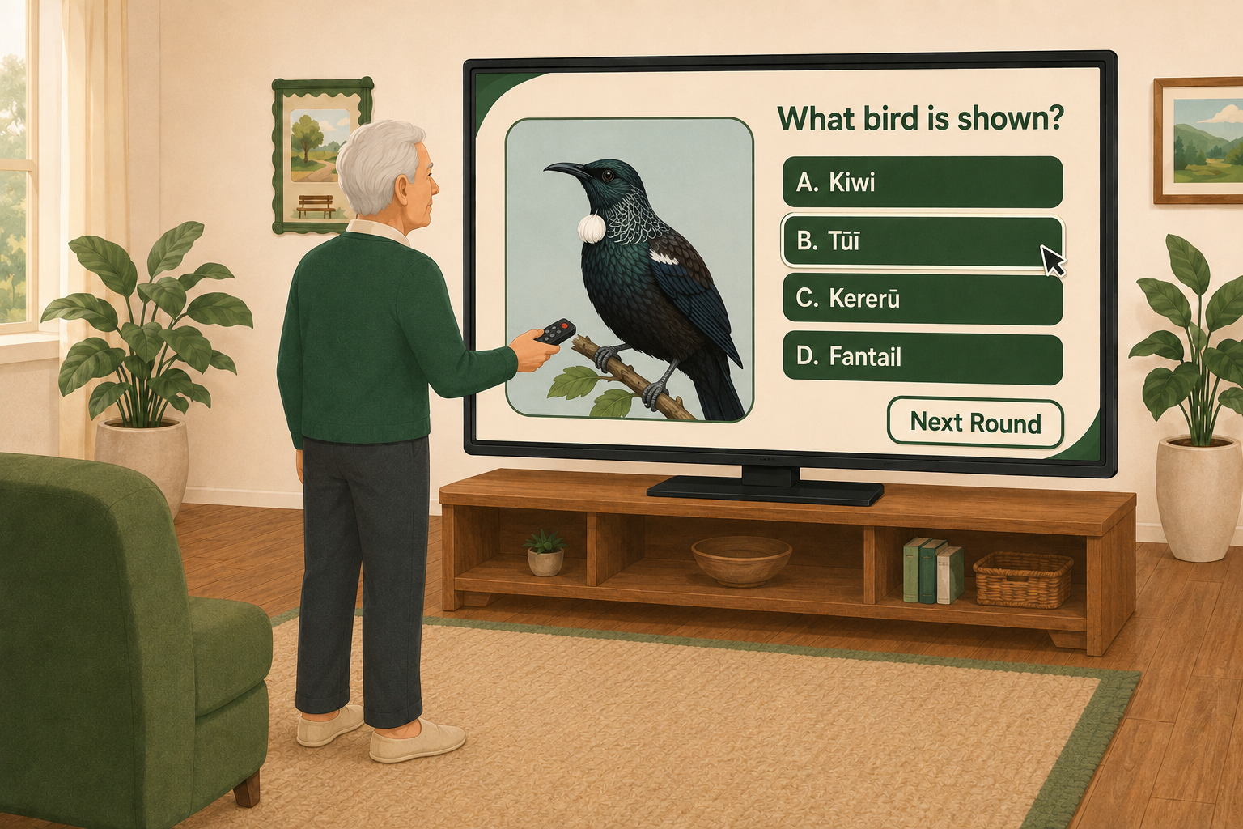
Figure 3. The player copies and briefly holds the posture as the shape approaches. | Figure 4. Completion of the movement sequence unlocks a short multiple-choice question.

Movement Sequence Design
Each Movement Round uses five to eight movements so that physical participation remains the central activity. Movements appear on the screen and allow time to observe, prepare, copy and hold. The sequence can mix upper-body and lower-body actions in standing mode while keeping intensity gentle. Movement examples include raising one arm, extending both arms, opening the chest, turning the upper body slightly, leaning gently to one side, lifting a knee while seated, or shifting weight with chair support.
The game rewards completion and safe adaptation. Exact pose accuracy does not determine points in the current prototype. This supports participants with different ranges of motion and avoids a sensor system adding device costs.

Quiz Design
After the movement sequence, one quiz question provides a brief cognitive change of pace. Questions should use plain language, one clear task and a limited amount of text. Four choices are suitable for familiar content; two choices can be used at an easier level.
Quiz category | Example focus
Nature and the Environment | Recognising native birds, plants, weather or landscapes.
Movement and Memory | Recalling which arm moved, the order of two actions or a visual detail from the sequence.
Te Reo Māori | Matching a familiar word with an image or meaning, following review by fluent speakers and community partners.
Picture Recognition | Identifying a person, object, activity or place shown briefly.
Music and Sound | Recognising a melody, instrument, bird call or environmental sound.
Healthy Living | Simple everyday wellbeing topics that avoid diagnosis or personalised medical advice.

Wellbeing Points and Tree Growth
The progression currency is named Wellbeing Points. It collects the points earned from previous movement game and it grows a virtual tree through five stages: Seed, Sprout, Young Tree, Growing Tree and Flourishing Tree. Individual points can grow a personal tree, while the same points contribute to a team or community tree. Shared progress supports collective celebration and reduces pressure from direct ranking.
Action | Wellbeing Points
Complete or safely adapt one movement | 2
Complete a full 5–8 movement sequence | 10 bonus
Answer the quiz question | 5
Select the correct answer | 5 bonus

